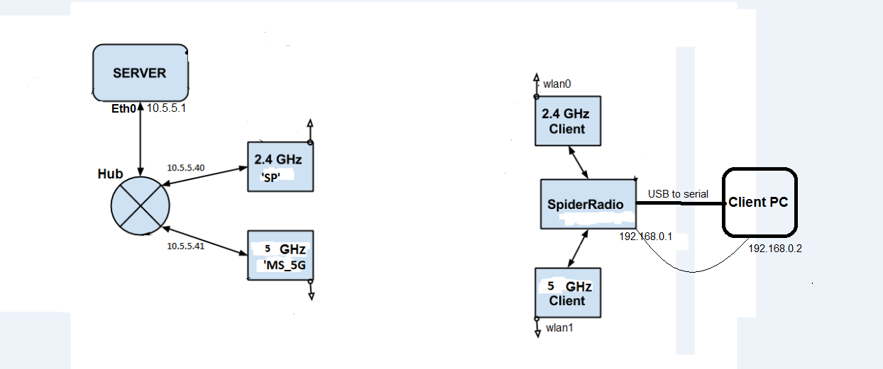

Server Setup

Username: malcolm
password: opennms

- cd tools
- sudo ./setup.sh

Spider Server setup
- cd setup
- sudo ./config.sh

Client Setup

Username: vsagar
password: enter123

1) Startup and connect the spider radio to the client PC via the USB to serial
- sudo kermit
- then press enter and login with above credentials

2) Connect to the wireless APs and configure routing tables
- cd bsol/ (vsagar@dsm1k3:~/bsol$)
- sudo ./setup.sh
-check that routing tables are added (rt1 & rt2)
- ip ru
-should look as follows:
vsagar@dsm1k3:~$ ip ru
0: from all lookup local
32762: from all to 192.168.6.6 lookup rt1
32763: from 192.168.6.6 lookup rt1
32764: from all to 192.168.5.101 lookup rt2
32765: from 192.168.5.101 lookup rt2
32766: from all lookup main
32767: from all lookup default

Starting Aggregation (tunnel)
On Server
- cd dsm
- ./vtund.server.sh

On Client (spider radio in desktop directory: vsagar@dsm1k3:~$)
- sudo killall -9 spidernetd
- sudo spidernetd s1 10.5.5.1 -f vtund_client.conf
-check if tun0 comes up in ifconfig
-if not, restart the process

Forwarding to client PC (make sure tun0 is up)
On Spider radio
- cd bsol/
- sudo ./client_forward.sh

On client PC
- sudo ifconfig eth0 192.168.0.2 up

Video streaming
On server
- cd /var/www/http
- vlc -vvv file_name --sout '#standard{access=http,mux=ogg,dst=10.3.0.1:8080}' --loop
- with transcoding: vlc -vvv input_stream –sout '#transcode{vcodec=mp4v,acodec=mpga,vb=800,ab=128}:standard{access=http,mux=ogg,dst=server.example.org:8080}' --loop
On client
- vlc http://10.3.0.1:8080

